[Date]

Dear [Name – i.e., Company Director],

RE: APPLYING FOR A DIRECTOR IDENTIFICATION NUMBER
Recent legislation has introduced new obligations for company directors requiring them to obtain a personal director identification number (‘Director ID’).
So, we are writing to highlight your new obligations and provide the appropriate information to ensure your ongoing director compliance.
This is particularly important as failure to comply with these new Director ID requirements may result in both civil and criminal penalties.
What is a Director ID?
A Director ID is a unique (15-digit) identifier that a director will keep forever (even if they cease being a director). This additional layer of identification verification has been primarily introduced by the Government to prevent the appointment of fictitious directors, and facilitate traceability of an individual director’s profile and their relationships with companies over time.
You will need to personally apply for a Director ID if you are an appointed company director (or even an alternative director). Note this also includes where you are a director of a company acting as a trustee (such as the corporate trustee of your SMSF or family trust).
Importantly, while our office can help you in understanding your new Director ID obligations, we are not permitted to make the application on your behalf (although we are happy to assist if and when required).
When do I need to apply for a Director ID?
When you must apply for a Director ID depends on the date you became a director (as outlined below).
Date you were/are appointed Date you must apply by
On or before 31 October 2021 30 November 2022
Between 1 November 2021 and 4 April 2022 Within 28 days of appointment
From 5 April 2022 Before appointed director
How do I apply for a Director ID?
Each individual director must apply for their own Director ID directly, to verify their identity via the ABRS website (abrs.gov.au), where you will click on the heading Apply for your Director ID.
For most directors, the three-step registration process can be done online and reasonably efficiently (i.e., in less than five minutes) provided you have all of the required documentation.
The three-step registration process comprises the following steps:
Step 1 – Set-up a myGovID (with a standard or strong identity strength)
A myGovID is different from myGov and is obtained by downloading and applying via the myGovID app to your smart device.
To set up a myGovID you will need to have (on hand) two Australian identity documents on which your name matches such as your driver’s licence or learner’s permit, passport, birth certificate, visa (using foreign passport providing still in Australia), citizenship certificate, ImmiCard or Medicare card.
Step 2 – Gather the documents required for identification
To apply for your Director ID you will need to have access to additional information the ATO knows about you such as your tax file number (TFN) and your residential address (linked to the ATO’s records).
You will also require information from two documents to verify your identity such as your bank account details, an ATO notice of assessment, your super account details, a dividend statement, a Centrelink payment summary or a PAYG payment summary (if applicable).
Step 3 – Complete your application
Once you have a myGovID with a standard or strong identity strength, and information to verify your identity at hand, you can log in and apply for your Director ID at the icon you see reproduced below for your reference.
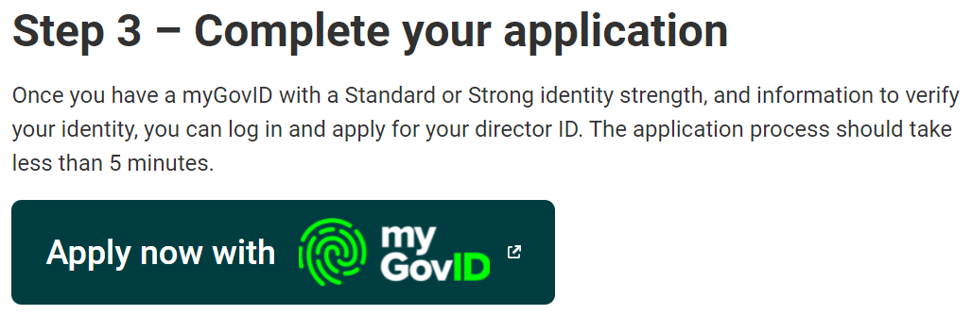
At this step your myGovID details and ATO details should be prefilled, and all you need to do is enter your place of birth, postal address, mobile number, and any former names before completing the declaration.
Please ensure your cybersecurity safety and take care when applying for your Director ID. Also, only apply online via abrs.gov.au.
Note: If you cannot get a myGovID (with a standard or strong identify strength), there are alternative mechanisms to obtain a Director ID via the phone or a paper form. The phone number is 13 62 50 for directors in Australia and for directors calling from overseas, the number is +61 2 6216 3440. If you can’t apply online or over the phone, you can apply using a downloadable form ‘Application for a director identification number’ (NAT 75329), although note this will be a slower process and you will also need to provide certified copies of your verification documents.
What do I do with my Director ID once I have successfully obtained it?
Once you have successfully applied for and obtained your Director ID, you will need to pass it onto the record-holder of any companies for which you are a director (e.g., the company secretary, another director, a contact person or an authorised agent of the company).
We would suggest you also retain the number for your own records as this will be your lifetime Director ID and required for any additional director appointments you have accepted, or will accept.
At this stage, no additional steps need to be taken to record your Director ID (e.g., with ASIC or the ATO).
Finally, please feel free to contact [me/alternate name] directly on [phone number] or at [email] if you need any assistance or clarification with respect to your new Director ID obligations.

Yours sincerely,

[Name of accountant / tax agent]

